**Documentation of Test Task**

Task Name: **Benchmark of MySQL vs PostgreSQL**

Project Solution Details are:

API Solution : **MySQLVSPostgresWithReact.sln**

Console Benchmark App Name : **Benchmarking**

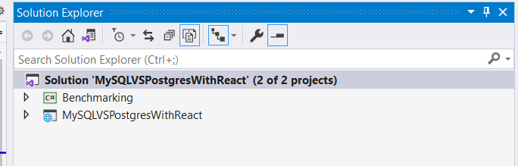

Here are the two projects that I have added one called Benchmarking (**Console App**) and another is MySQLVSPostgresWithReact (**using ASP.Net with React**).

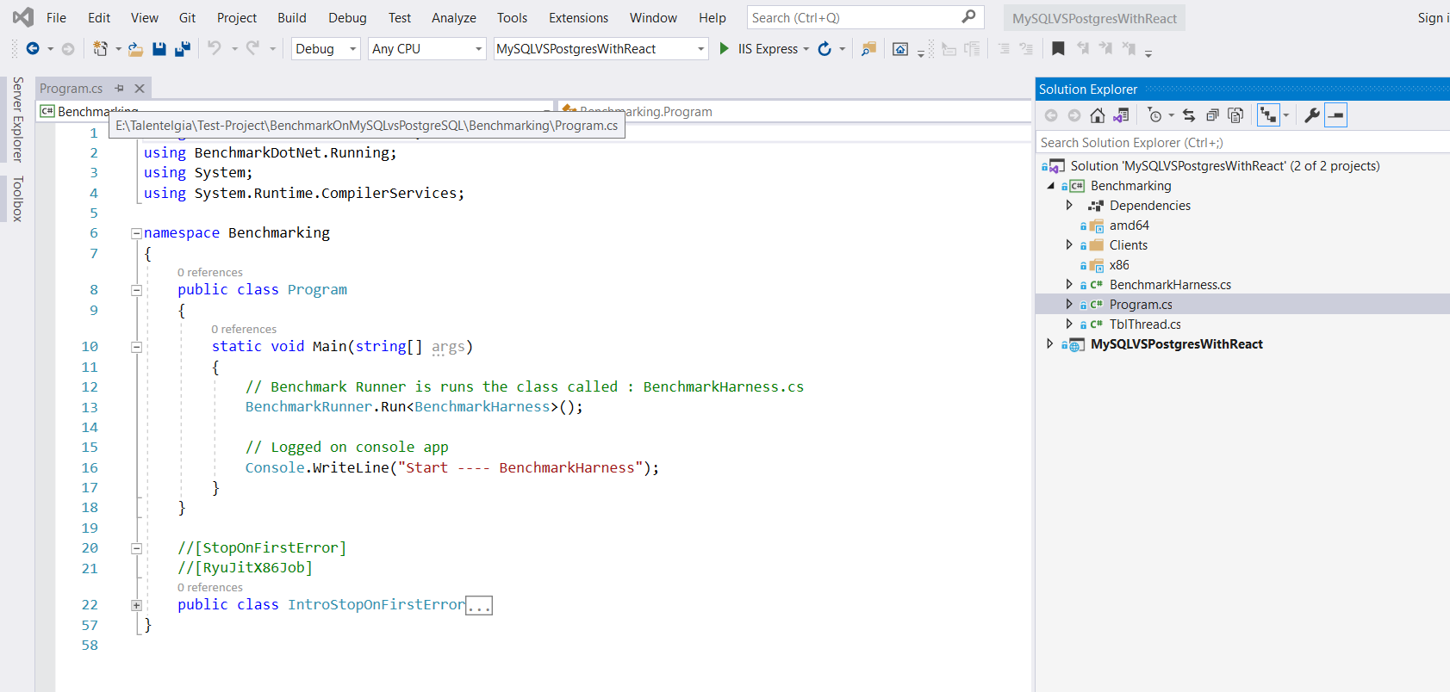

Benchmarking – project is containing Program.cs class and running **BenchmarkHarness.**

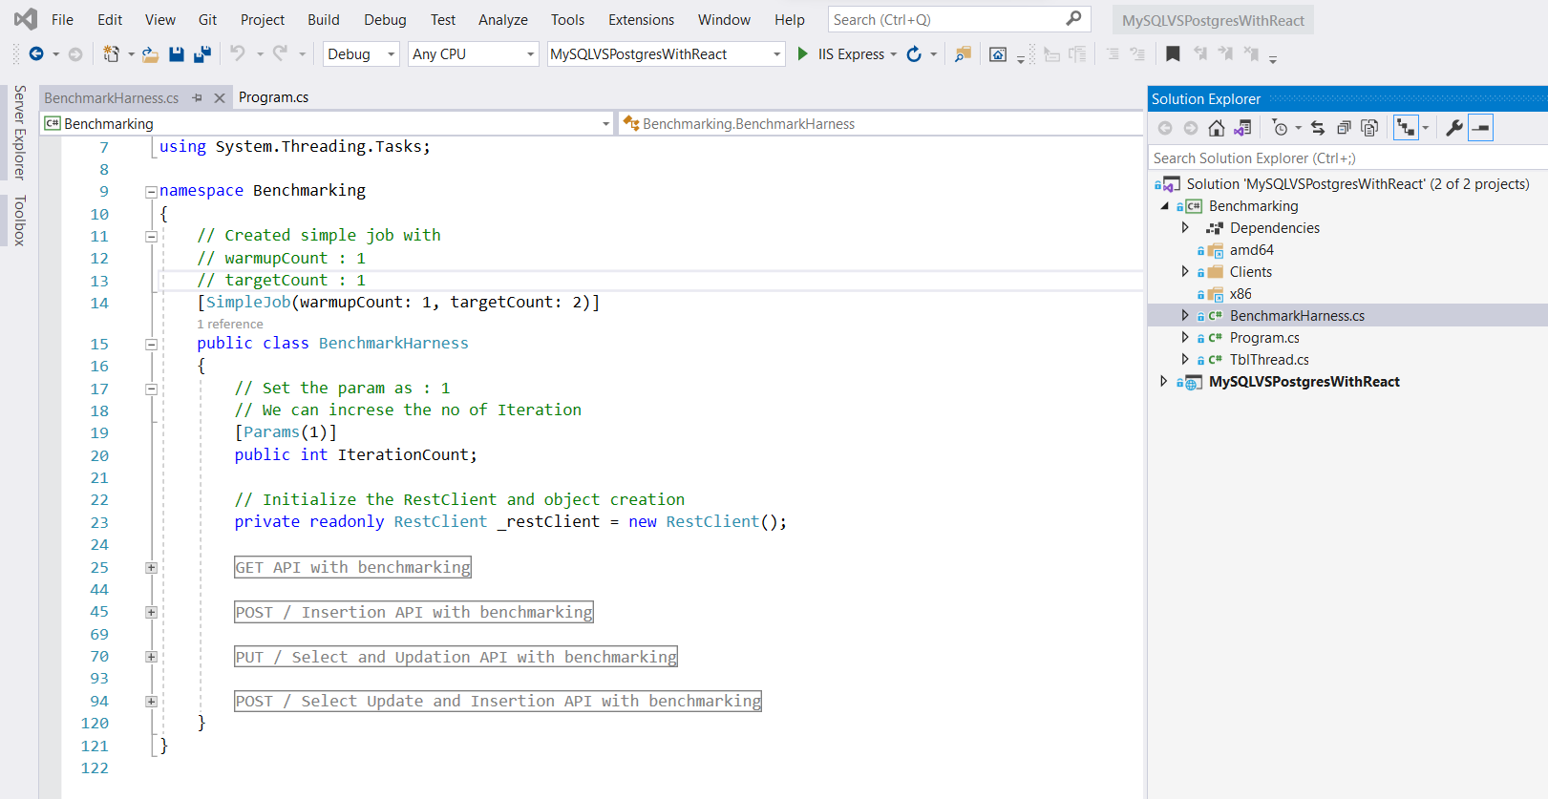

**Benchmarking.cs** containing all the methods need to be benchmark.

**Here is the list of methods :**

Method – 1: public async Task MySQLInsertion()

Method – 2: public async Task PGInsertion()

Method – 3: public async Task MySQLSelectPlusUpdate()

Method – 4: public async Task PGSelectPlusUpdate()

Method – 5: public async Task MySQLSelectPlusUpdatePlusInsertion()

Method – 6: public async Task PGSelectPlusUpdatePlusInsertion()

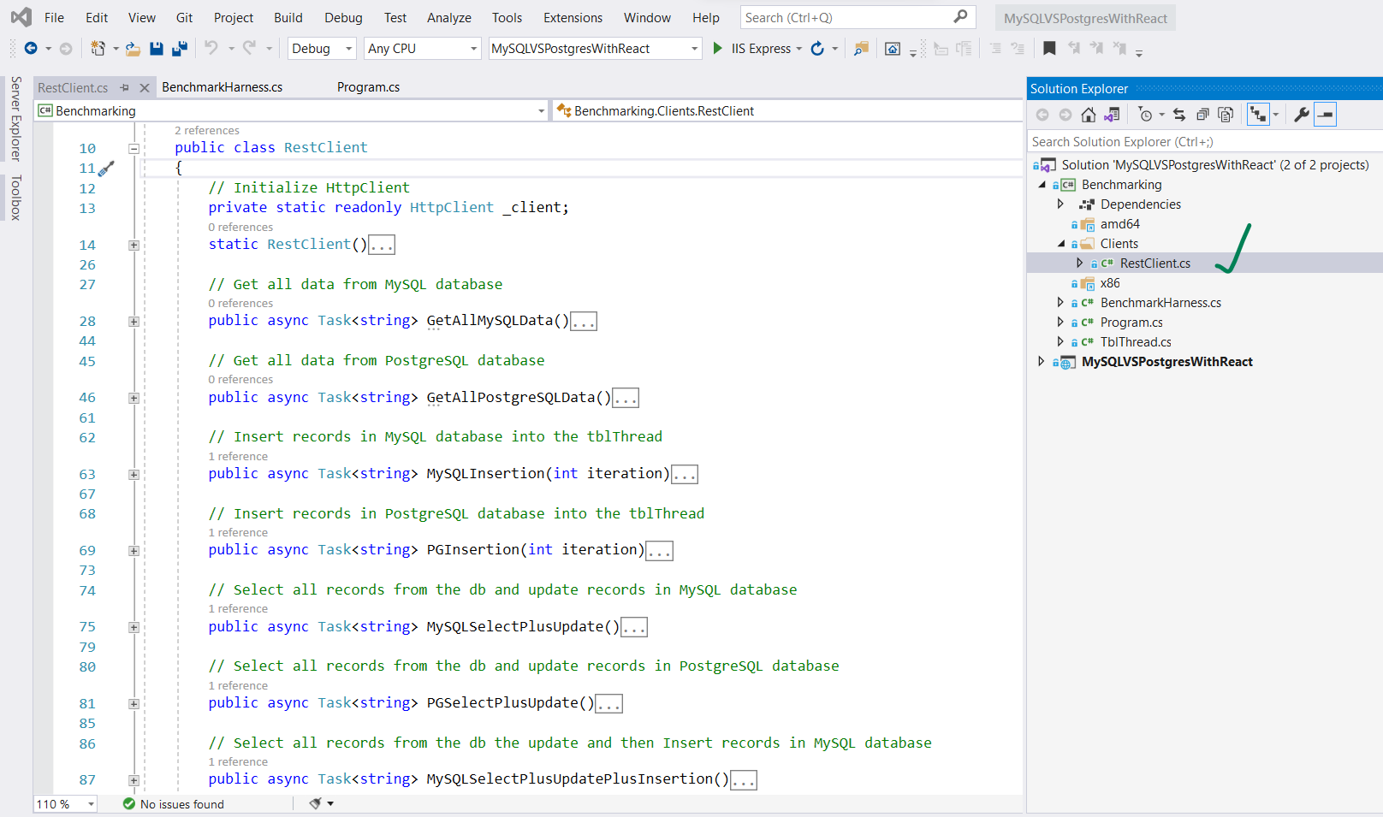

**RestClient.cs** containing all the communication with API at the time of running benchmark.

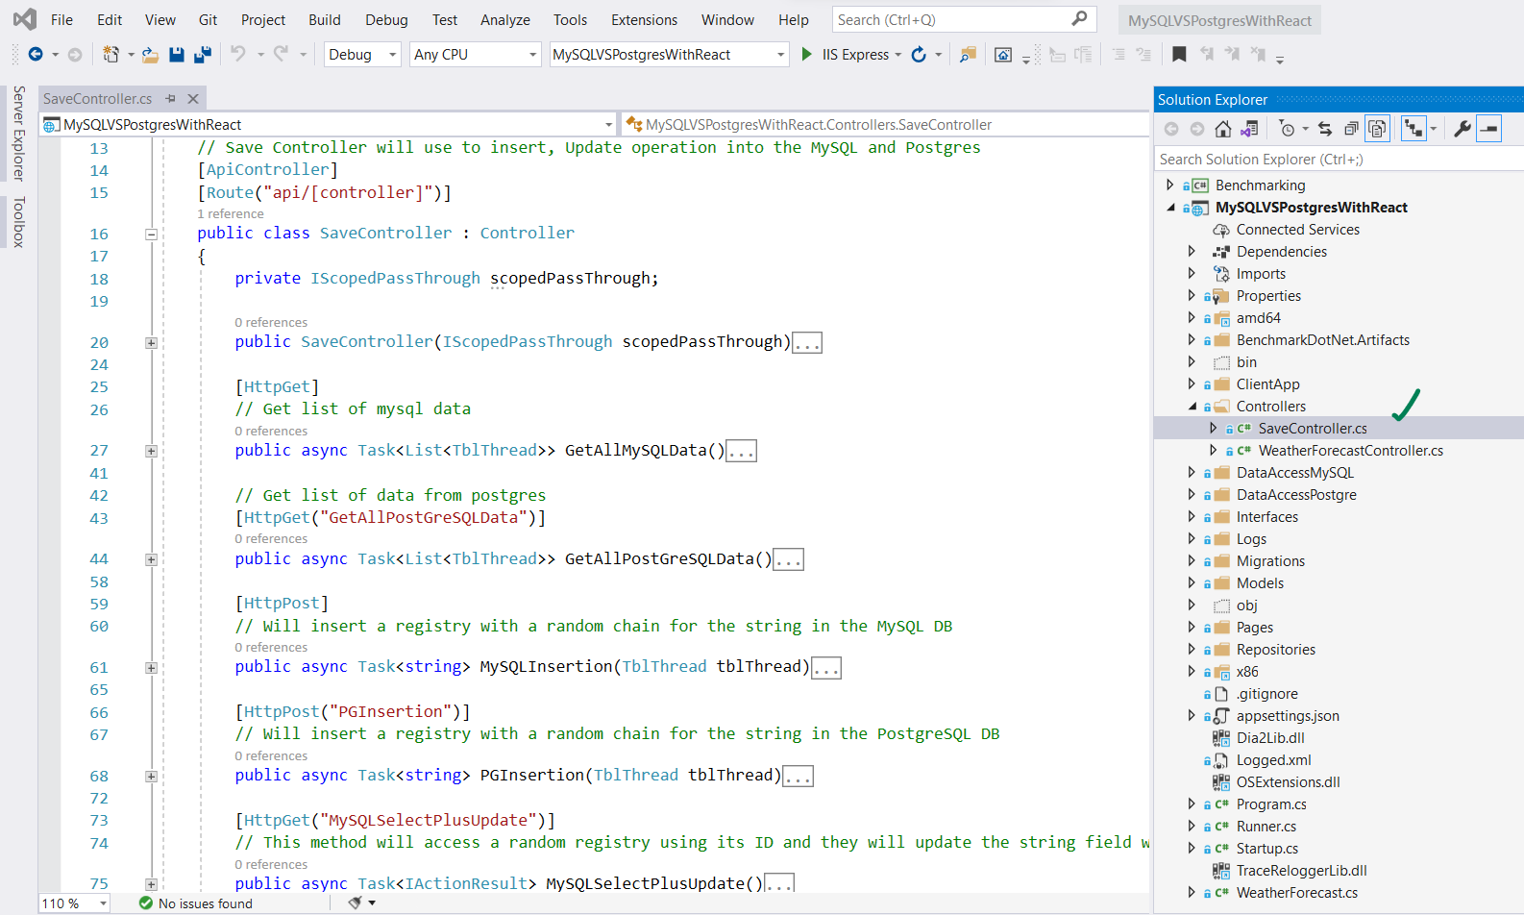

In the project “**MySQLVSPostgresWithReact**”, added one controller called “**SaveController.cs**” where all the API’s are located.

**Here is the list API’s that would call from the benchmark.cs at the time of benchmarking:**

API – 1: POST api/save

API – 2: POST api/save/PGInsertion

API – 3: GET api/save/MySQLSelectPlusUpdate

API – 4: GET api/save/PGSelectPlusUpdate

API – 5: GET api/save/MySQLcrud

API – 6: GET api/save/PGSQLcrud

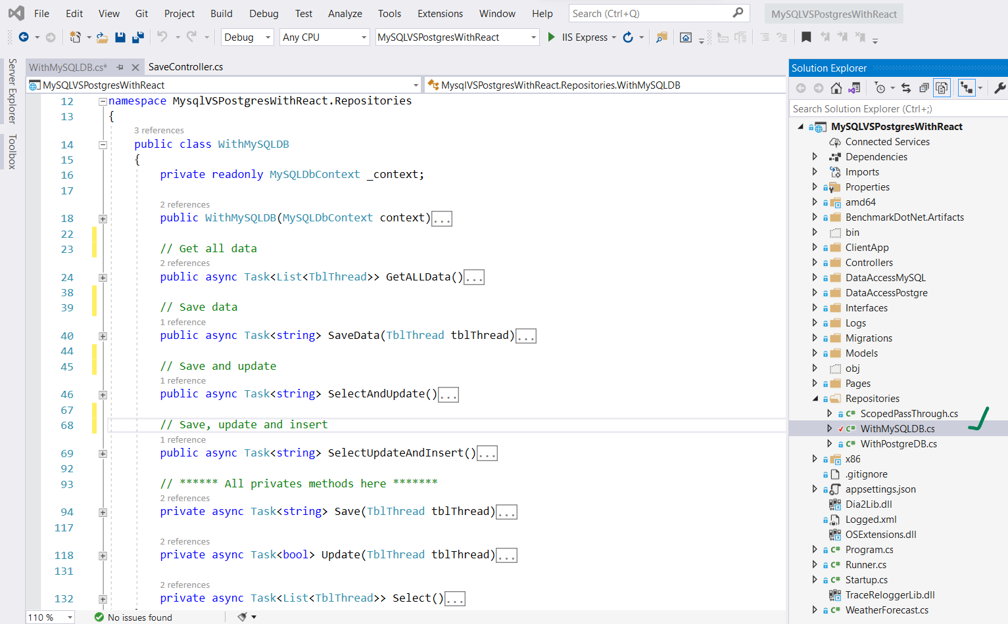

Inside the repositories added two classes one called “**WithMySQLDB**”, which is using to communicate with MySQL database.

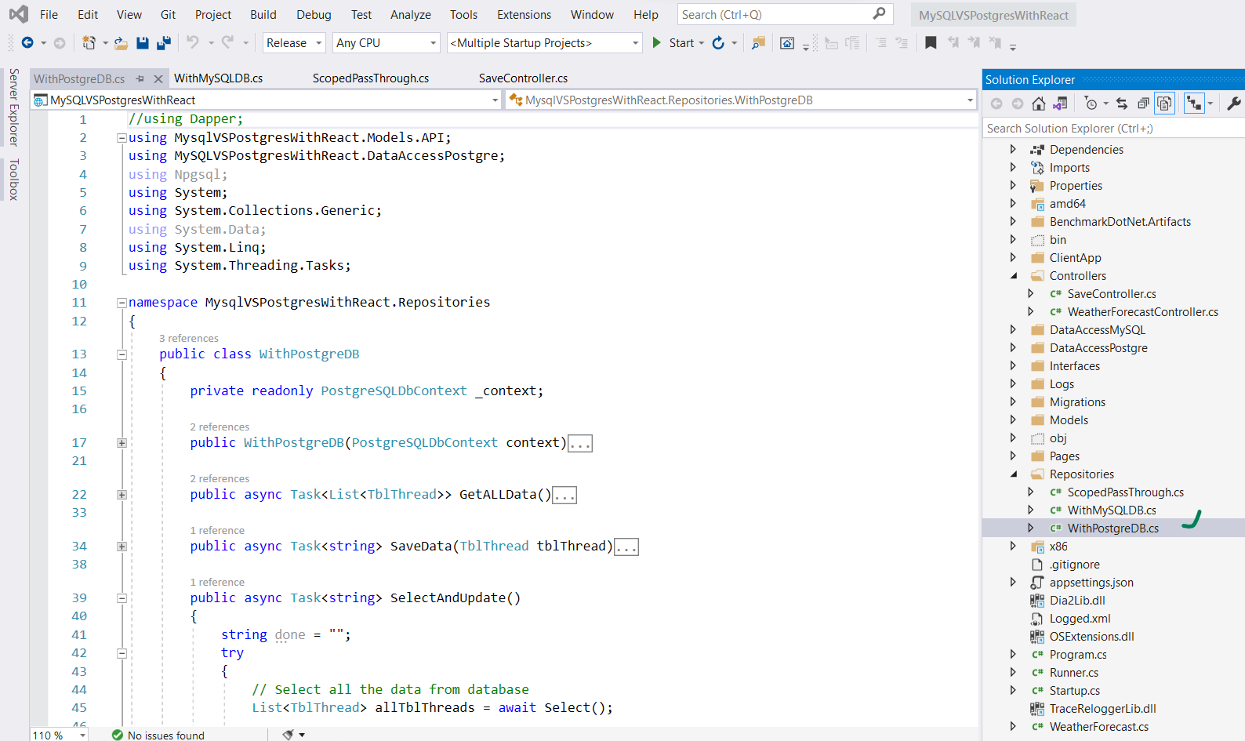

“**WithPostgreDB**” is communicating with PostgreSQL database.

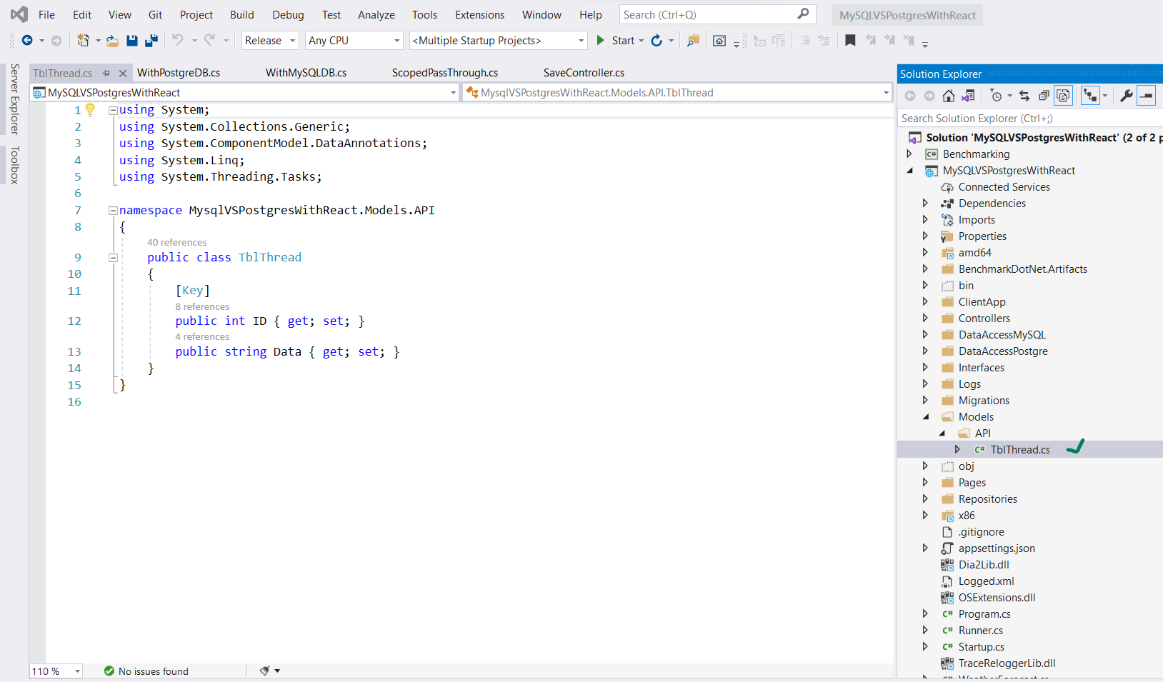

Table Name: **TblThread**

Is having two coloumns they are:

public int ID { get; set; }

public string Data { get; set; }

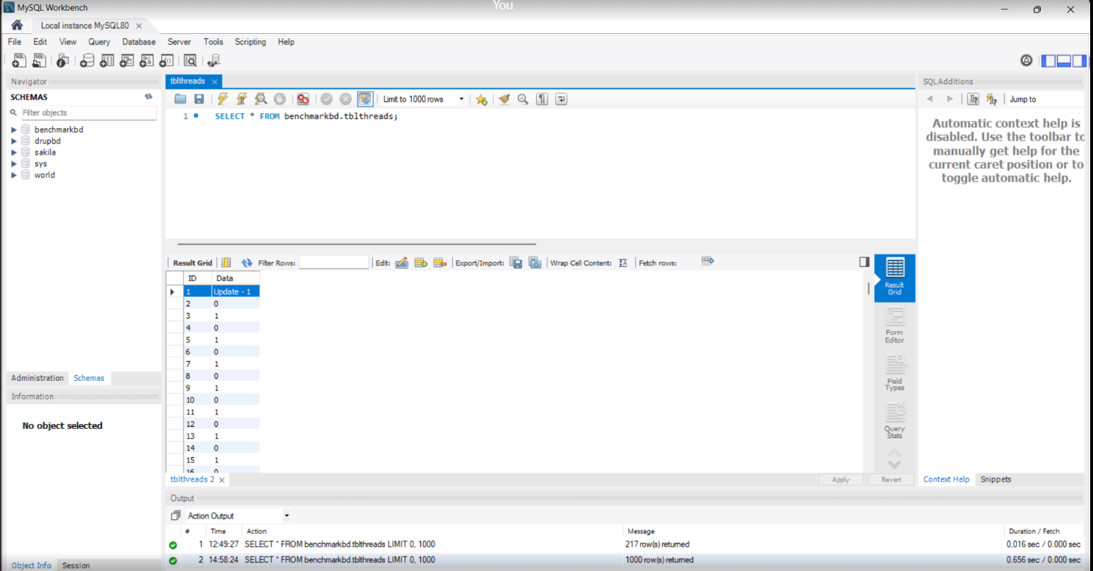

* This is **MySQL Workbench** where we can see that data are saved successfully at the time of benchmarking.

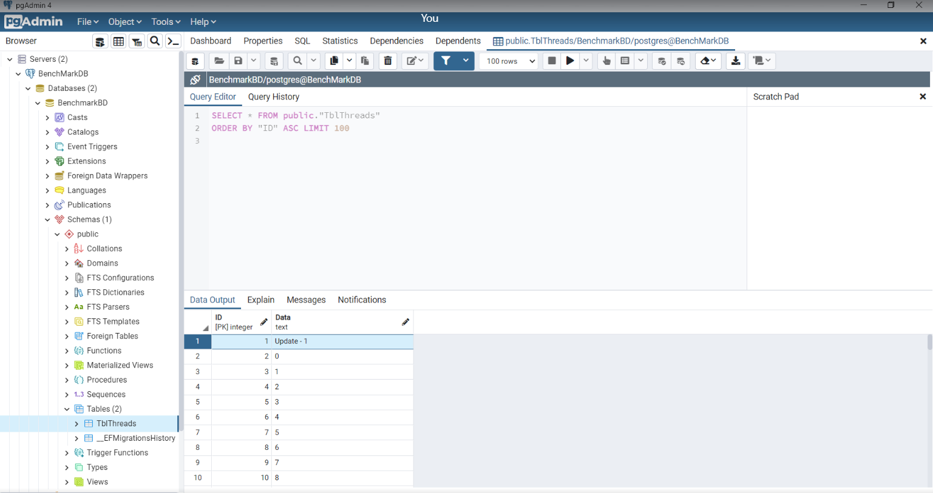

* This is **PostgreSQL pgAdmin4** where we can also see the data are inserted.

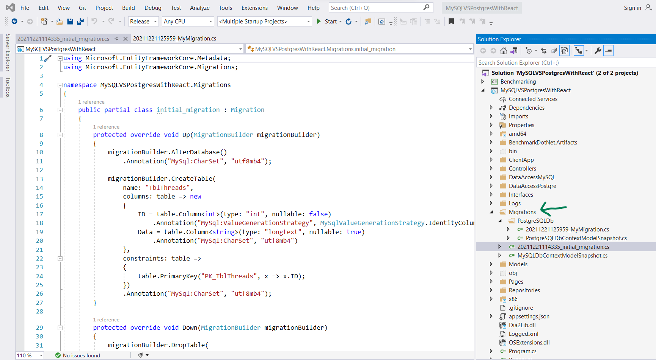

* In the **Migrations** folder are contains all the migration details of **MySQL and PostgreSQL** database.

**Commands that are need to executed / run the bellow command for database migration:**

* PostgreSQL Migration command

PM> Add-Migration 'MigrationName' -context **PostgreSQLDbContext**

PM> update-database -context **PostgreSQLDbContext**

* MySL Migration command

PM> Add-Migration 'MigrationName' -context **MyQLDbContext**

PM> update-database -context **MySQLDbContext**

**Output of the project:**

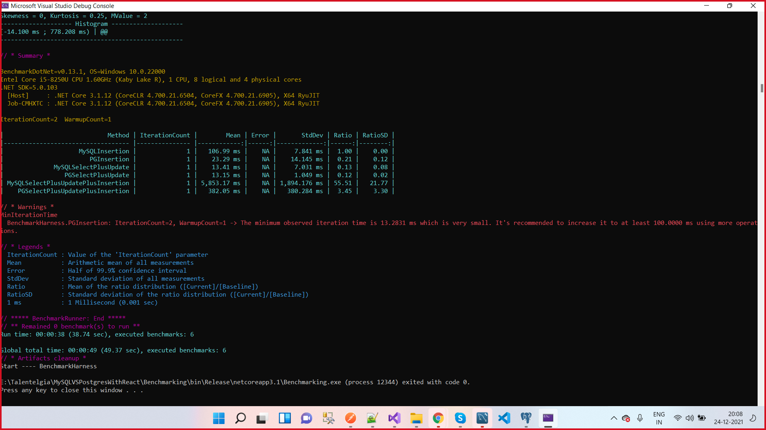

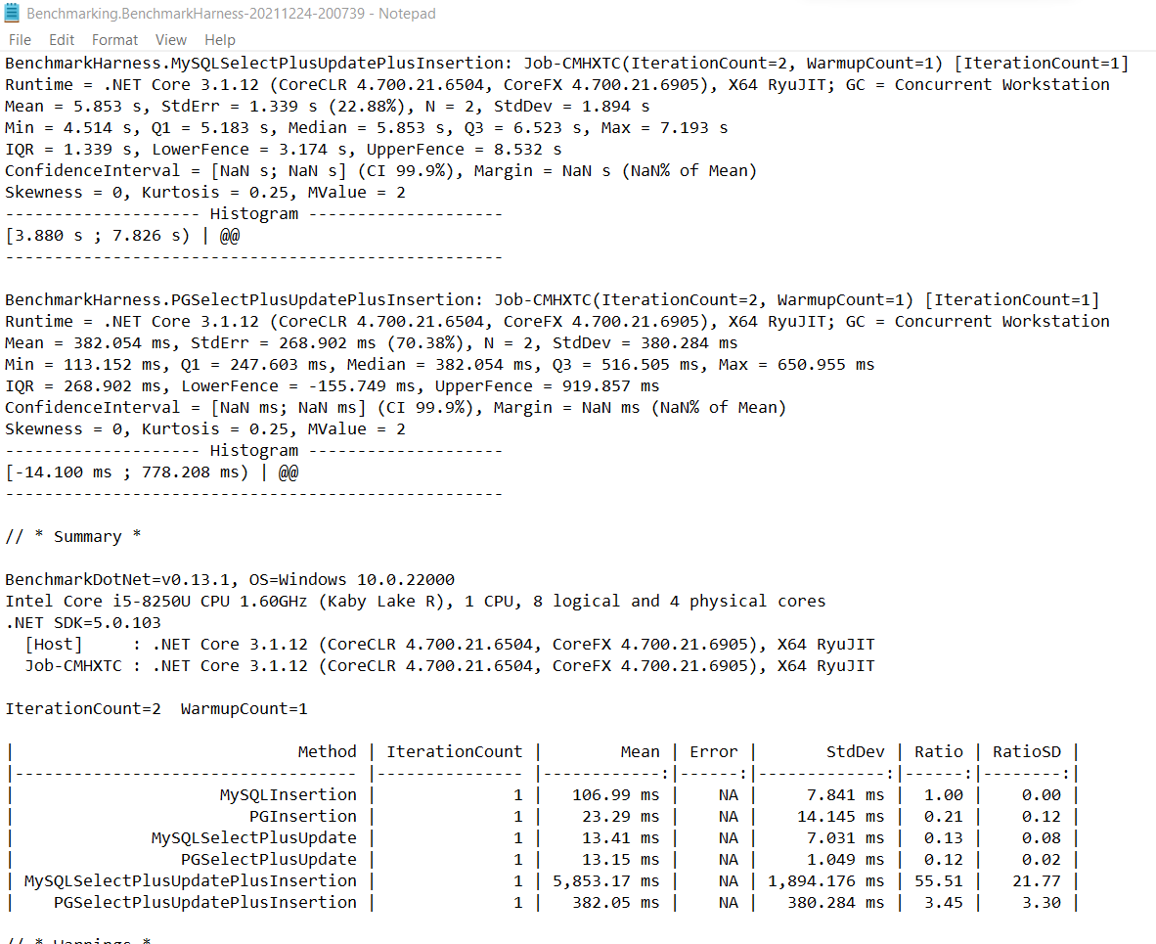

**Here is the result of full benchmarking with all the 6 methods.**